Teacher: Daniel Quillen Room: 528
Email: danielp.quillen@cms.k12.nc.us Webpage: http://quillenedmt330.weebly.com
Remind 101: Text the code provided for you class section to 81010
1st Hour Code | 2nd Hour Code | 3rd Hour Code | 4th Hour Code
@mrdquil1 | @mrdquil2 | @mrdquil3 | @mrdquil4
remind.com/join/mrdquil1 | remind.com/join/mrdquil2 | remind.com/join/mrdquil3 | remind.com/join/mrdquil4

Home Internet Access: Although most homes have access to the internet, some families still do not. Although home internet access is not required, it is highly desirable and greatly encouraged. As your student moves toward graduation and college and/or workplace, the ability to access current technology is critical for success. Please consider providing this opportunity for your student in your home this school year.
Course Description: This course is based on the NC Standard Course of Study for the 7th Grade. Throughout the course of this semester we will be learning about multiple subject areas and multiple topics within these Subject Areas.
Such subject areas are: Forces and Motions, Energy, Work and Simple Machines, Cells, Reproduction and Growth, Body Systems, Atmosphere, and Erosion.
Course Standards: This course is based on the NC Standard Course of Study. A copy will be available to you upon request. All students MUST pass the 7th Grade EOC with a score of 80% or greater to pass the class regardless of class performance.
Goal 1: Understand motion, the effects of forces on motion and the graphical representations of motion.
- 7.P.1.1 Explain how the motion of an object can be described by its position, direction of motion, and speed with respect to some other object.
- 7.P.1.2 Explain the effects of balanced and unbalanced forces acting on an object (including friction, gravity and magnets).
- 7.P.1.3 Illustrate the motion of an object using a graph to show a change in position over a period of time.
- 7.P.1.4 Interpret distance versus time graphs for constant speed and variable motion.
Goal 2: Understand forms of energy, energy transfer and transformation and conservation in mechanical systems.
- 7.P.2.1 Explain how kinetic and potential energy contribute to the mechanical energy of an object.
- 7.P.2.2 Explain how energy can be transformed from one form to another (specifically potential energy and kinetic energy) using a model or diagram of a moving object (roller coaster, pendulum, or cars on ramps as examples).
- 7.P.2.3 Recognize that energy can be transferred from one system to another when two objects push or pull on each other over a distance (work) and electrical circuits require a complete loop through which an electrical current can pass.
- 7.P.2.4 Explain how simple machines such as inclined planes, pulleys, levers and wheel and axels are used to create mechanical advantage and increase efficiency
Goal 3: Understand how the cycling of matter (water and gases) in and out of the atmosphere relates to Earth’s atmosphere, weather and climate and the effects of the atmosphere on humans.
- 7.E.1.1 Compare the composition, properties and structure of Earth’s atmosphere to include mixtures of gases and differences in temperature and pressure within layers.
- 7.E.1.2 Explain how the cycling of water in and out of the atmosphere and atmospheric conditions relate to the weather patterns on earth.
- 7.E.1.3 Explain the relationship between the movement of air masses, high and low pressure systems, and frontal boundaries to storms (including thunderstorms, hurricanes, and tornadoes) and other weather conditions that may result.
- 7.E.1.4 Predict weather conditions and patterns based on information obtained from:
• Weather data collected from direct observations and measurement (wind speed and direction, air temperature, humidity and air pressure).
• Weather maps, satellites and radar.
• Cloud shapes and types and associated elevation
- 7.E.1.5 Explain the influence of convection, global winds and the jet stream on weather and climatic conditions.
- 7.E.1.6 Conclude that the good health of humans requires: monitoring the atmosphere, maintaining air quality and stewardship.
Goal 4: Understand the processes, structures and functions of living organisms that enable them to survive, reproduce and carry out the basic functions of life.
- 7.L.1.1 Compare the structures and life functions of single-celled organisms that carry out all of the basic functions of life including:
• Euglena
• Amoeba
• Paramecium
• Volvox
- 7.L.1.2 Compare the structures and functions of plant and animal cells, including major organelles (cell membrane, cell wall, nucleus, chloroplasts, mitochondria, and vacuoles).
- 7.L.1.3 Summarize the hierarchical organization of multi-cellular organisms from cells to tissues to organs to systems to organisms.
- 7.L.1.4 Summarize the general functions of the major systems of the human body (digestion, respiration, reproduction, circulation, and excretion) and ways that these systems interact with each other to sustain life
Goal 5: Understand the relationship of the mechanisms of cellular reproduction, patterns of inheritance and external factors to potential variation and survival among offspring.
- 7.L.2.1 Explain why offspring that result from sexual reproduction (fertilization and meiosis) have greater variation than offspring that result from asexual reproduction (budding and mitosis).
- 7.L.2.2 Infer patterns of heredity using information from Punnett squares and pedigree analysis.
- 7.L.2.3 Explain the impact of the environment and lifestyle choices on biological inheritance (to include common genetic diseases) and survival.
Materials:
- Pencils /Pens – MANDATORY
- 3 or 5- Subject Spiral Notebook – College Ruled – MANDATORY
- Colored pencils &/or Skinny Markers – OPTIONAL
- 3 Ring Binder 1”-2”- MANDATORY
- HOME ACCESS TO THE INTERNET IS DESIRED AND HIGHLY ENCOURAGED!
Expectations: Students will come to class prepared to learn each day just as the teacher will be prepared to teach each day. Students will follow all school rules and CMS rules according to the Students Rights and Responsibilities handbook. This means all cell phones and iPods will be confiscated if they are visible whether they are turned- on or turned-off. Hats, caps, etc. are not allowed and will confiscated as well. The school dress code will be followed and students out of compliance will be sent to the office. The classroom rule “Do not interfere with my teaching or others’ learning,” as well as safety procedures will be enforced. Students will not be allowed to eat, drink, or sleep in class. If there are any discipline issues with your child the plan of action is as follows, but may be modified to fir the classroom and specific circumstances:
Consequences:
- Warning and/or parent contact
- Before/ After School Detention
- Parent-Teacher-Student Conference or Referral to Office
Attendance: Students will adhere to the school tardy policy. Students are expected to be in attendance at school each day. I close the door to my room immediately at the bell. Students remaining in the hall, even if they are right by my door, will be locked out. The only way to enter class after that is by having a teacher signed yellow pass. If a student is placed in lock-out, then that day is counted as an absence. Students who miss more than 11 days per class for any reason will receive a grade of “F” for the semester unless the CMS recovery plan is followed.

Make-up Work: Students are expected to make up any missed work due to an excused absence from class. It is the responsibility of the student to contact the teacher before or after class to discuss any assignments or schedule make up work. A station is available in the room where students may retrieve any handouts after an absence. Students usually have to complete make-up assignments before or after school, during their lunch, or at home.
Extra Help and Parent Contact: Students may come before school for extra help and to make up assignments or tests. If the student is a bus rider, they may request a pass the preceding day to be released from the bus early to utilize the time before school. If a student needs to stay after school for assistance, the parent or guardian must make prior arrangements with the teacher and plan on picking up their student at the arranged time discussed by the teacher and parent. No student may stay after school unsupervised without the teacher; this means students may not wait outside for parent pick-up without the supervising teacher. Students and parents may contact me by calling the school or email; however the best way to reach me is by email.
Additional Academic Support: We have access for outstanding on-line resources that will be encouraged for classroom and home use. These programs are excellent content skill builders and are designed to increase individual student reading and comprehension aptitudes. If your student must be absent for an extended period of time, these programs offer a way to stay current in class. Our department also offers various types of remediation after school. Students are strongly encouraged to participate in the opportunities provided.
Assessment Practices: Assessment will mainly be tests. Tests are divided into objectives and each objective is worth 100 points each. Students must pass with an 80% or better to pass the objective. If the objective is not passed the student may retake that particular objective until the objective is mastered on his or her own time as previously outlined. Students will be responsible for all information that has been presented since the beginning of the semester on each test. Additionally, students will be required to complete and correct a study guide in class before they are allowed to take the test. Students will also receive daily grades for class participation and work. I do not give homework frequently, however in that particular event, a grade will be given for the assignment. Assignments not turned in and tests not taken will be counted as “0.” I do not give extra-credit work to replace incomplete assignments.
Grading Policy: Grades will be calculated (approximated) using the following:
Formal Assessment: Tests/Quizzes/Projects/ Lab(s) – 65%
Informal Assessments: Classwork/Homework/Participation – 30%
Final Grades will be calculated using the North Carolina format as follows:
1st quarter 37.5%
2nd quarter 37.5%
Exam 25%

Grades will follow the North Carolina Grading Scale:
“A” Average– 100-90
“B” Average – 89-80
“C” Average – 79-70
“D” Average – 69-60
“F” Average – 59 and below
Wish List:
Construction Paper | Hand Sanitizer | Kleenex/ Tissue Paper
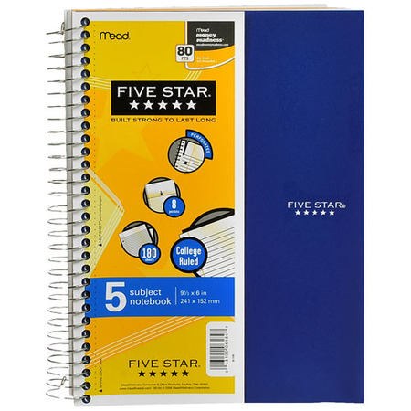
Supplies:
Needed by…
Monday, September 5th, 2016
-These supplies will be needed in each biology class at HHS, so if your student is transferred to another class the supply list will be the same.
5-Subject Spiral Notebook
I prefer the Five Star brand like is pictured below (these tend to hold up well for a semester); however, you may choose any 5-Subject notebook. I also like the type that has pockets for the subject dividers. You can find these notebooks at most any store and the cost ranges between $5 and $8.

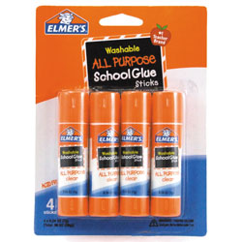
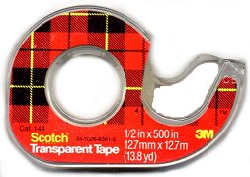
Glue Sticks or Scotch Tape
We will be creating an interactive science notebook where items are daily taped or glued onto the pages. Glue sticks or tape can be used. Some students prefer tape because they don’t like the messiness of glue. At least 3 (or more) glue sticks or 3 rolls of scotch tape will be needed.
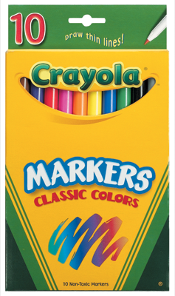

Thin-Line Markers
Crayola works great, but any brand will do.
Pens or Pencils:
Students are expected to have something to write with each day in every class. These are not provided freely by the school.

I ____________________________ hereby understand and agree to the following rules and expectations that are listed in Mr. Quillens’ 7th Grade Science Course.

Students Signature:_____________________________________ Date:_______________

Parents/Guardians Signature:____________________________ Date:_______________

